ECCOMAS Thematic Conference: International Conference on
Computational Evaluation of Head, Brain and Neck Injuries
(ICHBIN 2025)

TITLE

First A. AUTHOR∗, Second B. AUTHOR† AND Third C. COAUTHOR†
∗ Institution Department
Address, ZIP code, City, Country e-mail:

†Institution
Department
Address, ZIP code, City, Country e-mail:

Key words: Keyword1, Keyword2

Abstract. This document provides information and instructions for preparing the Ab- stracts of ECCOMAS ICHBIN 2025 Conference.

Communications consist into a maximum two-page abstract, possibly containing a figure and references. Figures can be included as follows.
The following example is a single line equation:
Ax = b (1)

Tables can be included as follows:

Table 1: Example of the construction of one table

C11 | C12 | C13
C21 | C22 | C23
C31 | C32 | C33
C41 | C42 | C43
C51 | C52 | C53

References can be quoted in the text by [1, 2].

First A. Author, Second B. Author and Third Coauthor

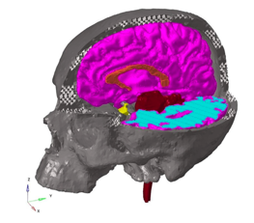

Figure 1: Head model.

REFERENCES
- Zienkiewicz, O.C. and Taylor, R.L. The finite element method. McGraw Hill, Vol. I., (1989), Vol. II., (1991).

